Develop A Web Application Using Node - RED

|  |  |
| --- | --- |
| Date | 31 October2022 |
| Team ID | PNT2022TMID31414 |
| Project Name | Project-IoT Based Safety Gadget For Child Safety Monitoring & Notification |
| Maximum Marks | 2 Marks |

Steps Followed:

* 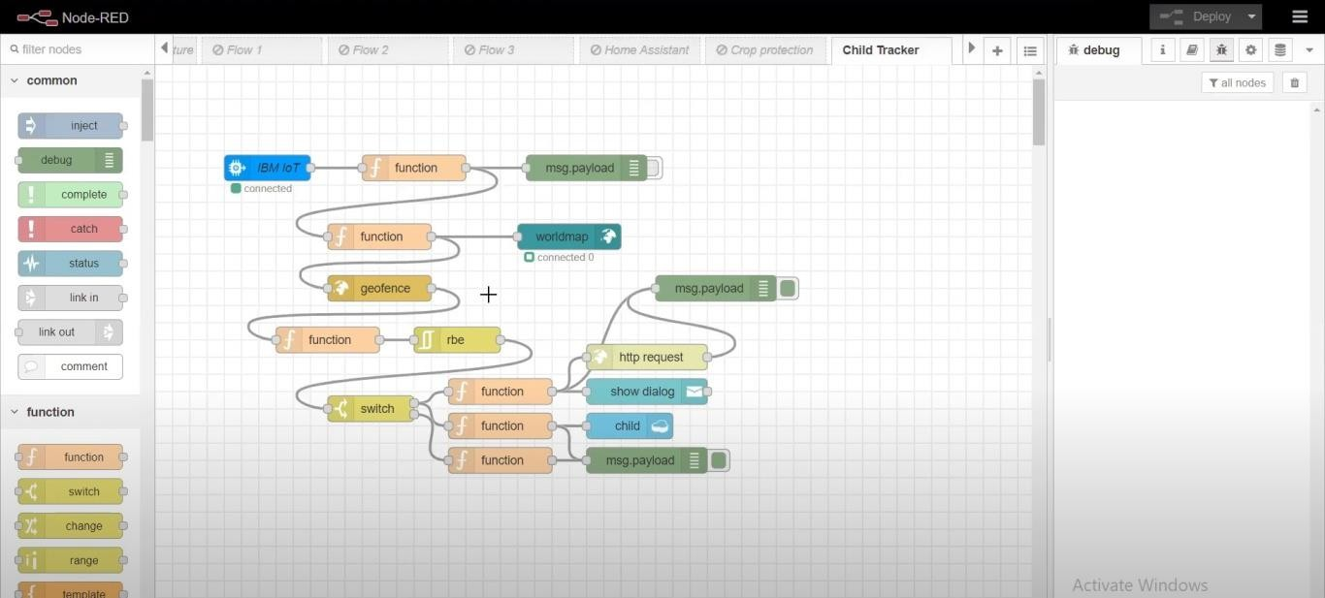Opened a Node-RED project
* Added code to get child location in python

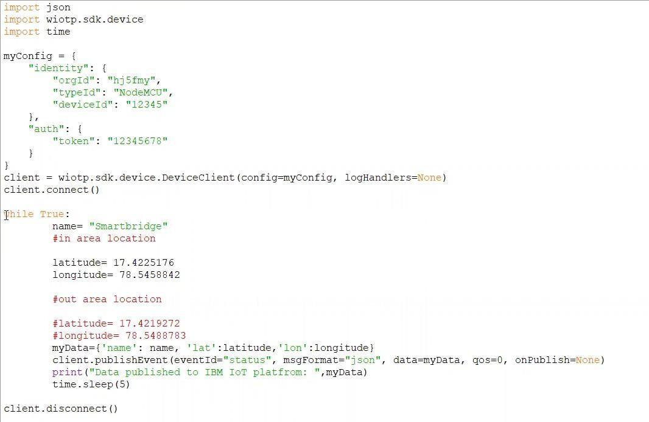

* 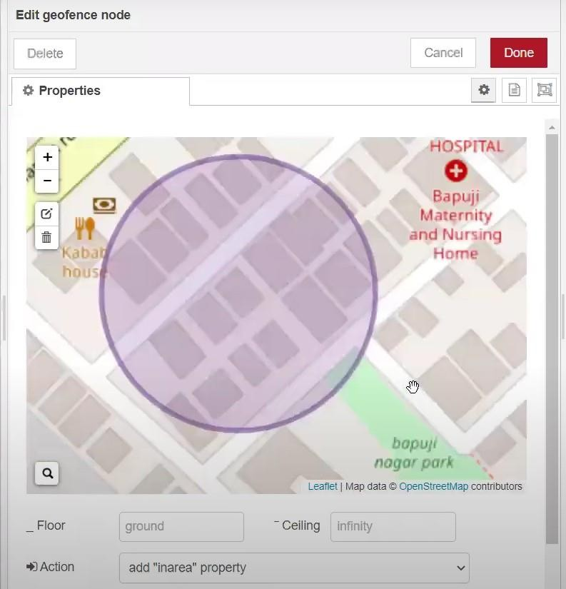Created the Geo Fence
* 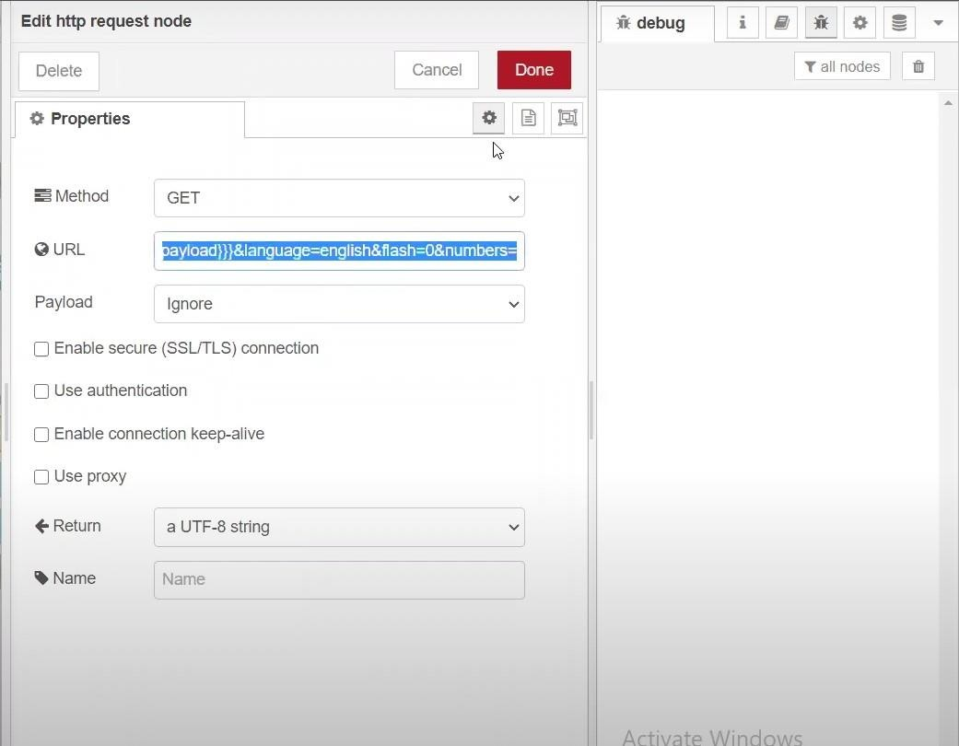Editing the HTTP Request URL
* Located the child

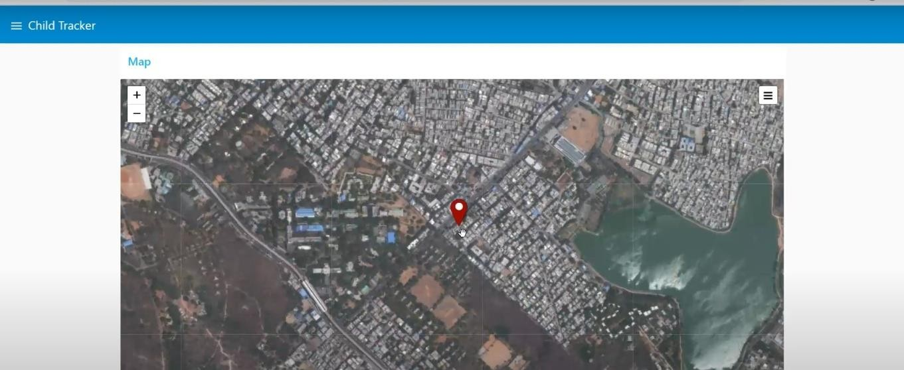

* 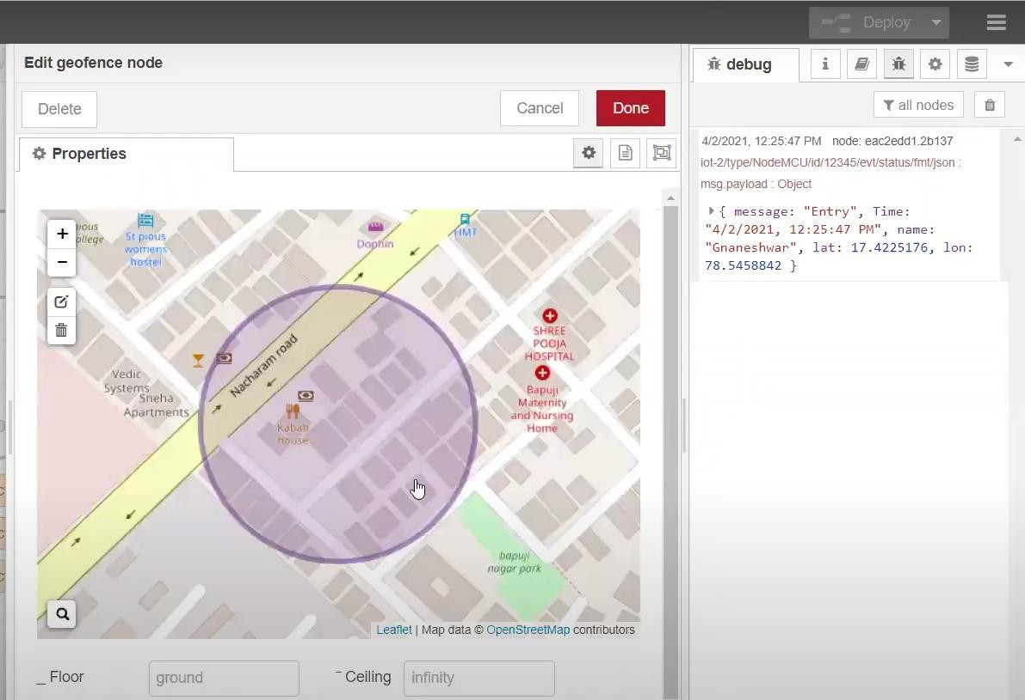Created the geo fence node
* Python script sending requests to IBM Cloud

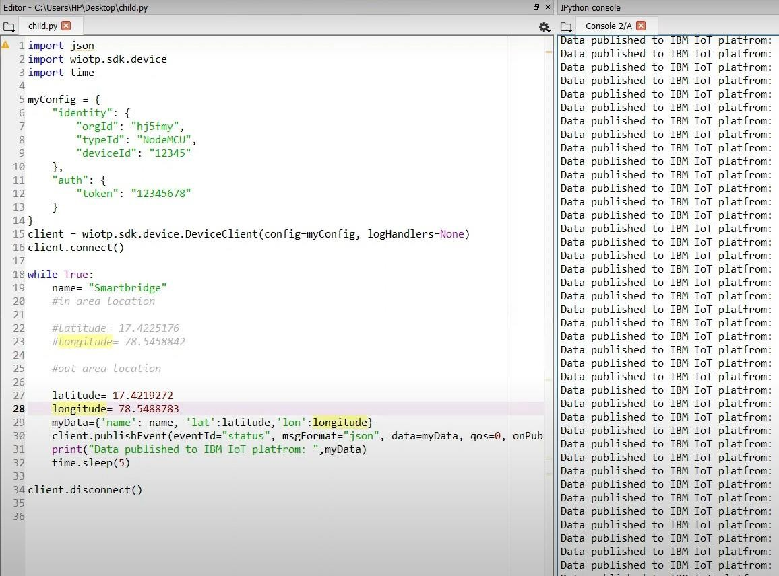

* After running the script, the web UI shows “Person is not in the particular area”

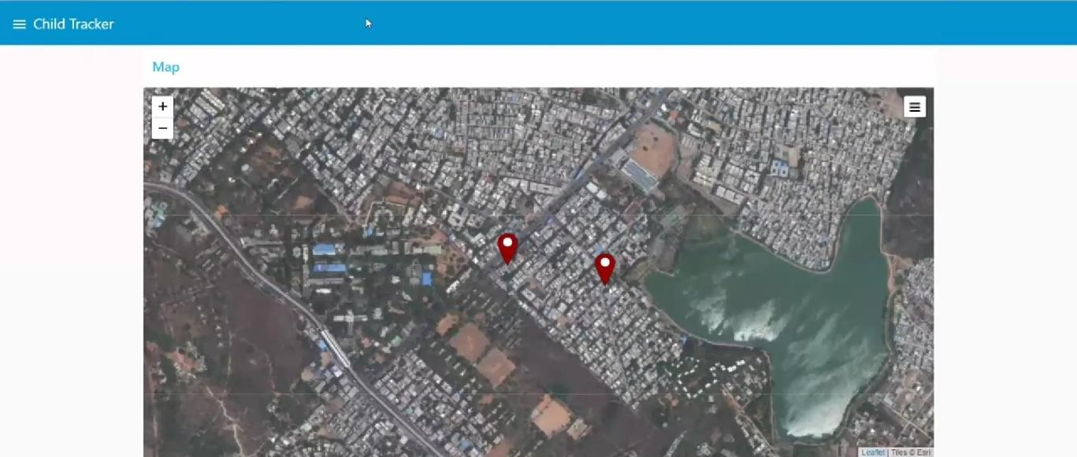

Result: Successfully developed a web application using Node-RED